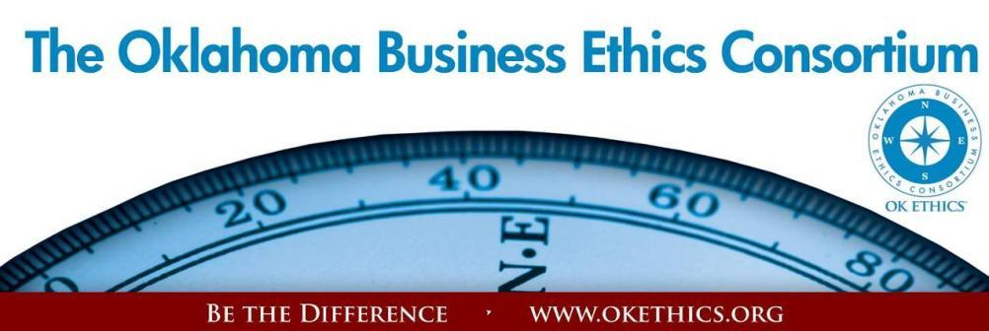

ENTERING OUR TENTH YEAR OF PROMOTING OKLAHOMA VALUES OF INTEGRITY AT WORK!
Agenda – April 17, 2013
- Welcome: Garyl Geist, President, OK Ethics Board of Directors
Chief Operating Officer, Oklahoma Allergy & Asthma Clinic
- Volunteer Appreciation
- Congratulations to 2013 Award Honorees! Shannon Warren, Founder, OK Ethics
Education Sector: | Large Company Category:
- Dove Science Academy  - Metro Technology Centers  - SandRidge Energy/Public Strategies  (for their work with for their outreach to Edwards Elementary, Moon Academy, Thelma Parks Elementary, Douglass Mid-High School) | 
Community Sector: | Mid-Sized Company Category:
- General Tommy Franks Leadership Institute (Hobart)  - Girl Scouts of Eastern Oklahoma (Tulsa)  - Oklahoma Center for Non-Profits | 

- Introduction of Keynote Speaker Eric Chester Randy Thurman, OK Ethics Board of Directors
and Co-President and CFO, Retirement Investment Advisors
HONORABLE MENTION TO HERTZ AND CFS2!
REMINDER: PLEASE PICK UP CPE’S AT CONCLUSION OF EVENT.
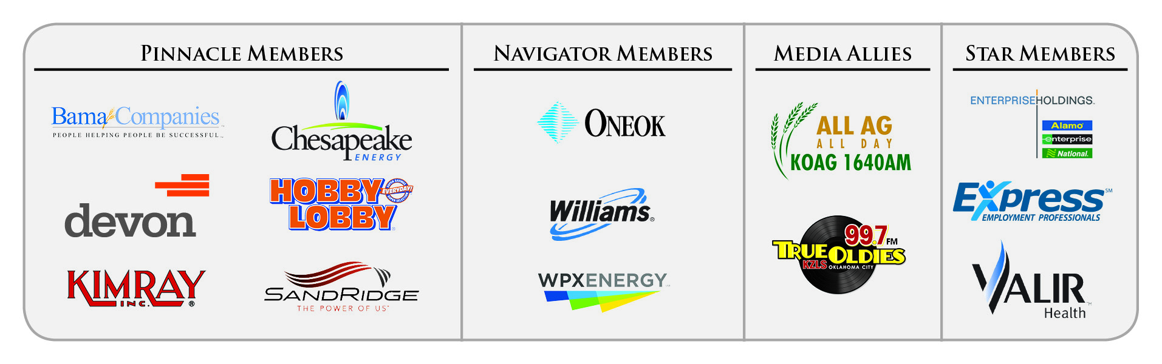
VOLUNTEER APPRECIATION

OK Ethics relies primarily on volunteers to achieve the organization’s successful pursuit of Oklahoma’s values of integrity at work. It takes leadership and teamwork to host these exciting events and we salute your dedication in achieving OK Ethics’ mission! Listed below are today’s volunteers who consistently provide service to our members:
Agendas: Many thanks to the volunteers from Metro Technology Centers who provide our monthly agendas.

Ambassador Team: These friendly people welcome our guests each month and assist in helping them locate seats. They also arrive early to help distribute agendas and assist with name tags.
Linda | Streun | Ideal Homes | Chief Ambassador
John | Burnett | Character First | Ambassadors (Lead – Team 1)
Brent | Martens | Accounting Principals | Ambassadors (Lead – Team 2)
Deborah | Burroughs | Langston (Retired) | Ambassadors
Jamie | Gorman | Hyde & Co. | Ambassadors
Wayne | Hart | Legal Shield | Ambassadors
Jenny | Hatton | Boeing | Ambassadors
Tammy | McKeever | Enterprise Holdings | Ambassadors
Daniel | Yunker | Kimray, Inc. | Ambassadors
Ben | Robinson | Sentry One LLC | Ambassador (Executive Team)
Tom | Shehan | Nextep Inc. | Ambassadors (Executive Team)
Registration Team: These dependable individuals diligently record our guests’ attendance and handle the collection of fees:
Mark | Neumeister, CPA | D. R. Payne & Associates | Registration Chairperson
Mary | Vaughan CPA | JMA Energy | Guest Registration (Cash & Visitors)
Joe | Walker | Arledge & Associates | Pre-paid Registration Chairperson
Marvinette | Ponder | Devon Energy | Pre-paid Registration – Lead
Questions? Want to volunteer? Visit www.okethics.org ▪ Or call (405) 889-0498 for Member Care Coordinator, Jalisha Petties ▪ Email warrenokla@cox.net for Founder, Shannon Warren
Volunteer Appreciation (continued):

Special Initiatives:
Michael | Mount | Oklahoma Accountancy Board | CPE's
Susan | Pate | Stinnett & Associates | Accountant
Jalisha | Petties | OK Ethics | Member Care Coordinator
Connie | Root | Walker Companies | Speaker Gifts
Shirley | Mears | Champlin Broadcasting | Announcements on  Morning Drive (99.7)

TUNE IN! Our own Bob Byrne and Shirley Mears featured on the morning drive for True Oldies Channel FM 99.7 – Tune in between 7:00 and 8:00 a.m. to learn more about Oklahoma’s legacy! Also, hear interviews with speakers thanks to Champlin Broadcasting and the folks with the Oklahoma Heritage Association who provide the research for our historic profiles!
DID YOU KNOW?
▪ OK Ethics’ outreach to university students has greatly increased. Part of your membership dues are earmarked to sponsor student ethics activities on thirteen Oklahoma campuses and our Foundation sponsored a Statewide Educators Ethics Symposium that was attended by approximately 70 academic leaders representing nearly 20 educational institutions.
▪ Non-profits (e.g. 501c3 and professional organizations) can join any time for free as Frontier members in OK Ethics?
- Upcoming Events: Tulsa Chapter
“Navigating Change with Ethics In Mind”
Thursday – April 25
Doubletree Hotel – Downtown Tulsa

  Robyn Ewing,  Senior Vice President and Chief Administrative Officer,  The Williams Companies |   Marcia MacLeod,  Senior Vice President,  of Human Resources &  Administration  WPX Energy

OKLAHOMA BUSINESS ETHICS CONSORTIUM ~ www.okethics.org

Upcoming Events: Oklahoma City Chapter

ANNUAL COMPASS & COMMUNITY IMPACT AWARDS
Wednesday, May 15
Petroleum Club - OKC
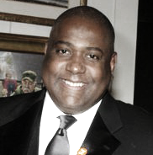
“THE REPUTATION DOCTOR IS IN”

MIKE PAUL
President, MGP & Associates Public Relations; NYC
Special discounts for Horizon Members and early bird registrations.
See website for details

Recommended for 1 CPE in Ethics

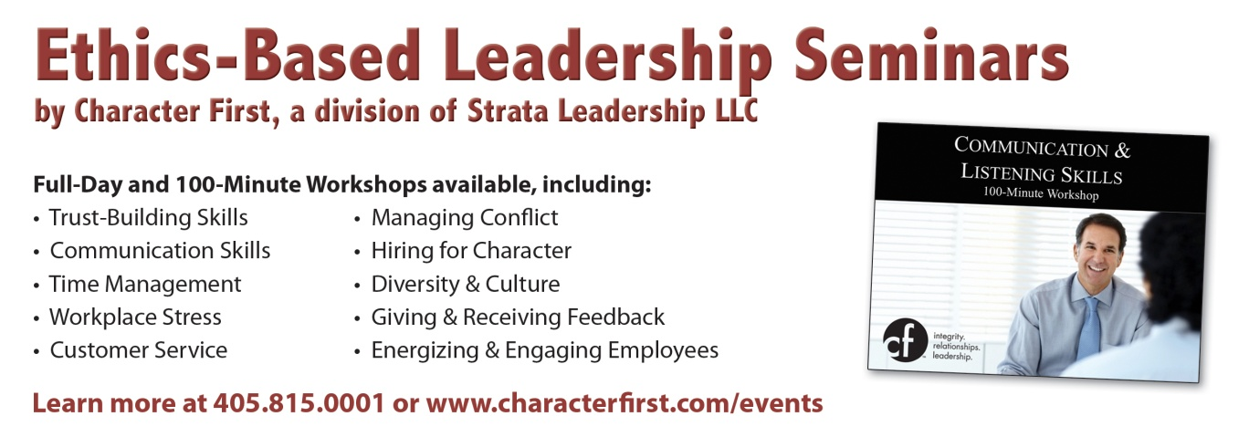
Programs Focused on Integrity - (Not affiliated with OK Ethics)
Since the beginning, OK Ethics members have been inspired by our friendship with Character First. Leaders with this organization provided the wisdom and insight for OK Ethic's Guiding Principles. Go to www.characterfirst.com to learn more about tools to help you integrate character and ethics into your organizational culture, or contact John Burnett at 405-815-0001

OKLAHOMA BUSINESS ETHICS CONSORTIUM ~ www.okethics.org

“Reviving Work Ethic in an Age of Entitlements”
Value Added: Developing People from the Inside Out

About Our Presenter:

Presented by Award Winning Keynote Speaker and Bestselling Business Author, Eric Chester
Eric Chester is America’s premier expert on the emerging workforce. As the author of the bestselling books “Employing Generation Why” Eric frequently appears on national media (i.e. Forbes, FoxNews, Business Investor Daily, Fast Company, Entrepreneur.com, etc.) to provide insight and perspective to business leaders about the attitudes, values, and work habits of teens and the under-thirty‐year‐old demographic in their school-to‐work-to-career transition. His latest book, Reviving Work Ethic: A Leader’s Guide to Ending Entitlement and Restoring Pride in the Emerging Workforce, is the first business book published on the topic of work ethic since 1904 and provides the solutions for the work ethic deficiency employers in every industry are facing. In addition to his writings, Eric Chester is an award-winning keynote speaker who’s presented more than 2,000 paid speeches since 1987 for audiences all over the world. In 2011, Chester founded the Center for Work Ethics Development, an organization dedicated to helping leading companies, educational institutions, and non-profit organizations improve the work ethic, productivity, performance, and service of today’s rapidly changing workforce. The training curriculum and resources he has created through this Center are being used at hundreds of high schools, colleges and workforce centers throughout the United States and Canada by a growing number of service sector businesses as their first step in new employee training.

As a keynote speaker, Eric Chester holds the prestigious CSP (Certified Speaking Professional) credential awarded by the National Speakers Association, its highest earned designation. He is a 2004 inductee into the CPAE (Council of Peers Award of Excellence) International Professional Speakers Hall of Fame, an honor shared by less than 2% of all professional speakers in the world.


Program Overview:
Research proves that most business leaders are not satisfied with the performance, productivity, and the service they are getting from their emerging workforce. The problem is not so much a skills gap as it is a values gap which is apparent when analyzing the core work ethic values a growing number of employees are bringing to the job. This is the cause--and the effect--of Eric Chester's compelling presentation based on his new groundbreaking book, Reviving Work Ethic. With his hilarious and unconventional style of delivery, Chester will help you build the 7 essential work ethic values within your people to ensure their success, and the success and sustainability of your business.

Recommended for 1 CPE in Ethics at the basic level. Program is suitable for anyone in a leadership capacity who desires to promote a culture of ethical behavior. See additional details below:

Without detracting from the spontaneity of the program, general takeaways will include:
1) Success factors
2) Identifying responsibility and accountability
3) Fundamentals for establishing a culture of integrity
4) Respectful engagement
Special note for CPE’s: Because of the spontaneity of the program, participants seeking CPE credit are urged to take notes in case of an audit. Also, it is up to the individual attendees to demonstrate applicability to his/her own area of practice. OK Ethics makes no guarantees. Also, please be sure to pick up your CPE certificate at the end of the program as OK Ethics does not have the volunteer manpower to send these after the event has concluded.
General Program Disclaimer:
Members of the Oklahoma Business Ethics Consortium frequently share information concerning various issues and developments that may have legal implications. The discussions, commentary, and handouts at Consortium meetings or presentations to other organizations are for general informational purposes only. They cover only some aspects of the subject topic, and do not constitute a complete legal analysis of the topic or how it might apply to any particular set of facts. Before taking any action based on information presented during a Consortium event, participants are encouraged to consult a qualified attorney. The observations and comments of presenters at Consortium meetings and networking are the views and opinions of the presenter and do not constitute the opinion or policies of the Consortium or any of its members.
Interested in Receiving OK Ethics Monthly Meeting Notices?

OKC:
Contact Jalisha Petties, Member Care Coordinator
at (405) 889-0498 or via email okethics@yahoo.com

Interested in joining OK Ethics?
Contact Lynda Mobley, Vice President of Membership; Lynda.Mobley@oneok.com

Presenters are respectfully requested to avoid profanity, preaching, politics, put-downs and self-promotion during their lectures


PLEASE LIKE ETHICS ON FACEBOOK

OKLAHOMA BUSINESS ETHICS CONSORTIUM ~ www.okethics.org

Oklahoma Business Ethics Consortium Guiding Principles
Adopted July, 2004
To ensure that the Consortium fosters positive characteristics of integrity in the successful achievement of its goals, these Guiding Principles were discussed and adopted (with revisions) during a milestone planning session held by Consortium leaders in Stroud on June 18, 2004. These principles were developed based on the Character First's values and philosophies.
I. Responsibility to Self and Others:
- Service:
  - Passion for promoting ethics and integrity
  - Encouraging the promotion of ethical behavior through personal actions and
  - Sharing ideas and resources
  - Responsibility and accountability for fulfilling the mission of the Consortium.
- Collaboration:
  - Achievement of common goals through the promotion of ethical, mutually beneficial relationships
  - Service to the Consortium over promotion of self-interest
  - Cooperation emphasized over competition in promoting ethical business conduct
  - Members collaborate by being constructively engaged in discussions regarding ethics
  - Seeking consensus in interactive discussions regarding ethical matters.
- Respect:
  - Members may become aware of confidential information shared by others in an effort to determine an ethical course of action. We ask members to be sensitive in recognizing and respecting the efforts made toward achieving ethical behavior. In that vein, public disclosure of this information is discouraged.
  - We respect other members and the process by:
    - Exhibiting listening skills and actively listening to discussions
    - Being open to other points of view and outcomes
  - We are an inclusive organization and demonstrate this by welcoming members who are in different stages of learning as applied to ethical behavior.
II. Lead with Integrity
- Dependability:
  - Members are asked to demonstrate their support of this initiative by consistently attending meetings.
- Initiative:
  - Recruiting other members who have demonstrated a desire to promote ethical behavior in their organizations.
  - Recognizing what needs to be done to help promote the Mission of the Consortium and taking action to assist in that effort.
- Honor:
  - Members are asked to honor the Consortium through the practice of integrity and ethical behavior in their business dealings.
  - We express gratefulness to our hosts, sponsors and speakers; as well as to those whose volunteer service makes OK Ethics a stronger organization.
  - Realizing that each of us is in a mode of continual learning, we demonstrate humility, care and compassion when sharing our thoughts and knowledge.
- Courage:
  - Speak the truth with confidence and encourage others to do the same.
III. Inspire Trust
- We serve and promote the cause of truth with integrity, objectivity and fairness to all persons.
  - We hold ourselves accountable by consistently honoring our word.
  - We extend trust abundantly to those who have earned it.
  - Trust, once earned, will not be taken for granted, manipulated or abused.

